READ ME

In between the base and client b levels, there is an intermediary layer or "glue" known as the CRUD Python Module. This is what links the database to the user and allows its use and access.

## Installation links:

[www.mongodb.com](http://www.mongodb.com) - Mongo

[www.python.org](http://www.python.org) - Python

# Getting started with Mongo

1. Install MongoDB, project1.py and the project2.py to get started
2. Initiate the Mongo server with no authentication.
3. 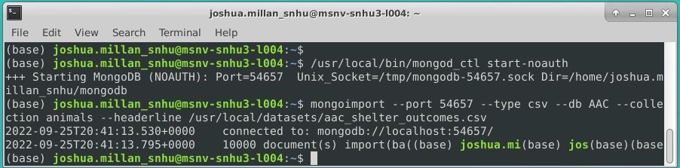
4. Type “mongo” to start the program.
5. Text

   Description automatically generated
6. Once you have successfully created an admin account to exit
   1. Exit
   2. */usr/local/bin/mongod_ctl stop*
   3. */usr/local/bin/mongod_ctl start*
7. Text

   Description automatically generated
8. Now you have admin rights to the databases which will allow you to add and edit information.

# Usage

Create function to add new information to database

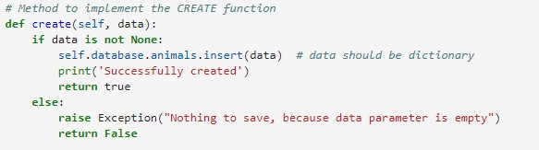

Read function pulls the information out of the database

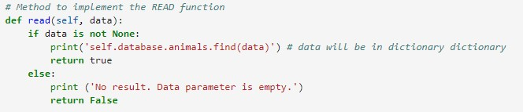  
Delete function gets rid of unwanted information from database

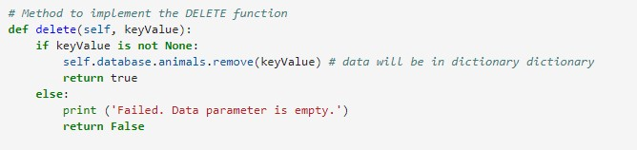

Update function changes information on the database

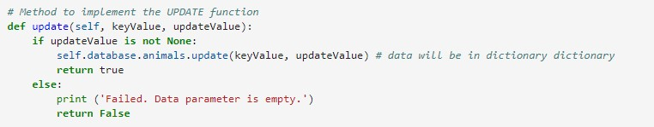

Test create to ensure that the function works

Test read to ensure that the function works

Test update to ensure that the function works

Test delete to ensure that the function works

MAP

This code shows the location of the selected rows that should come up when program is ran.

Graphs

This displays all information in a pie chart divided by breed, rather than just that which is specified in the table.

Radio

Allows you to move between options and resets

Table

This section shows all the values

# Did it work?

In the end it should have pulled up a graph with all the information on the animlas in the selter. Also, you’re supposed to be able to see all information and interact with the graph. Sicne I wanst able to get it to work for project one and I couldn’t get logged in to the mongo server I was not able to get it to display anthing.